p-

Exam of Digital Communications
a.a. 2020-2021
Feb. 24, 2021

Exercise #1

A message signal m (t) = cos 2000πt + 2 cos 3000πt modulates the carrier c (t) = 100 cos2πfct, where fc = 1 MHz.

- Sketch the spectrum of the lower SSB modulated signal
- Find the complex envelope for the modulated signal

ct 50 E^2000pi ft + 100e^3000 pift
Exercise #2
A signal has a bandwidth of 8kHz. It is sampled, logarithmically compressed and encoded into a PCM format using 8bits per sample. The PCM data is transmitted through an AWGN channel via M-level PAM. Determine the minimum bandwidth required for the transmission when
- M=4;
- M=8;
- M=16.

Exercise #3

In an additive white Gaussian noise channel with noise power spectral density of N0/2, two bits are transmitted by

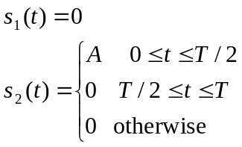

The two messages are transmitted with a priori probabilities p and (1-p), respectively.

- Determine the average energy transmitted per bit 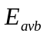
- Determine the optimum threshold
- Determine the structure of the optimal receiver (including the detector after the sampler)
- Determine the probability of error in case p=(1-p)=0.5.

Exercise #4

If the maximum BER is 10(-4) and SNR is 15dB, which constellations guarantees the maximum bit rate? What is the maximum theoretical bit rate in case with no ISI if the bandwidth available is 3kHz?

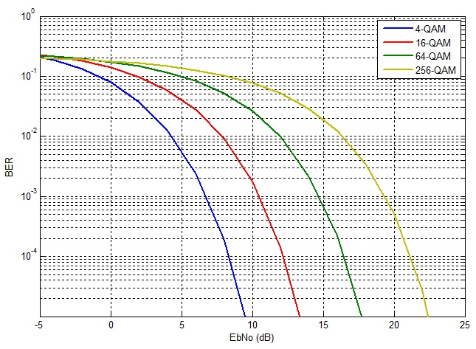

Exercise #5
Let us consider two channels that are modeled as linear filter and AWGN. The impulse responses of the two channels are drawn below:

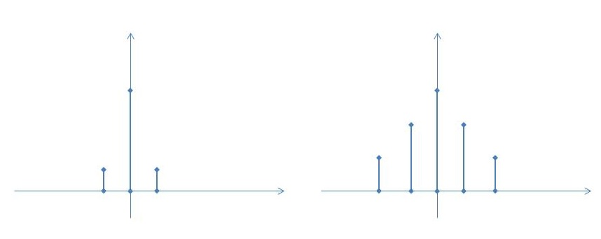
- (b)

- In which case is more important to use an equalizer at the receiver?
- When the equalizer is not used, how do you expect that the BER curve look like?

